Terracotta /n/: unglazed, typically brownish-red earthenware, used chiefly as an ornamental building material and in modeling; an unglazed, clay-based material. Usually very porous. Comes from the Latin (terra cocta) Italian (terra cotta) meaning baked earth in the early 18th Century. It is a medium that is used all around the world, across centuries, in a variety of ways (as you can see below).
------------------
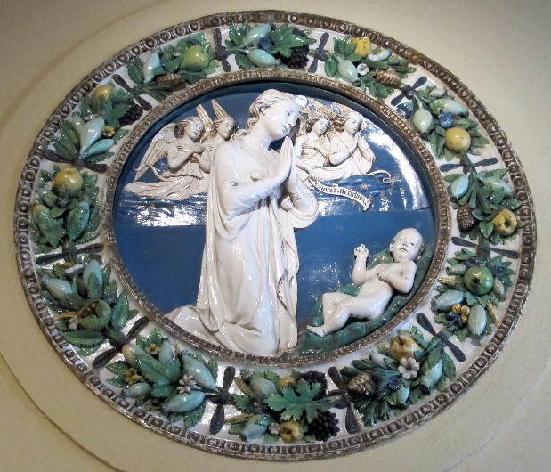
Roundel by Luca and Andrea della Robbia (glazed)
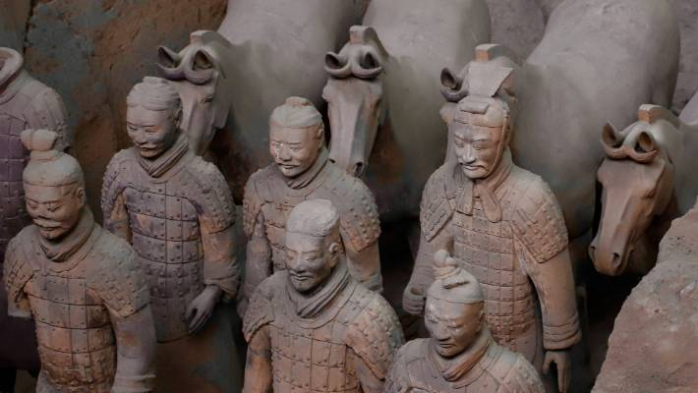
The Terracotta Warriors, Xi’an, China
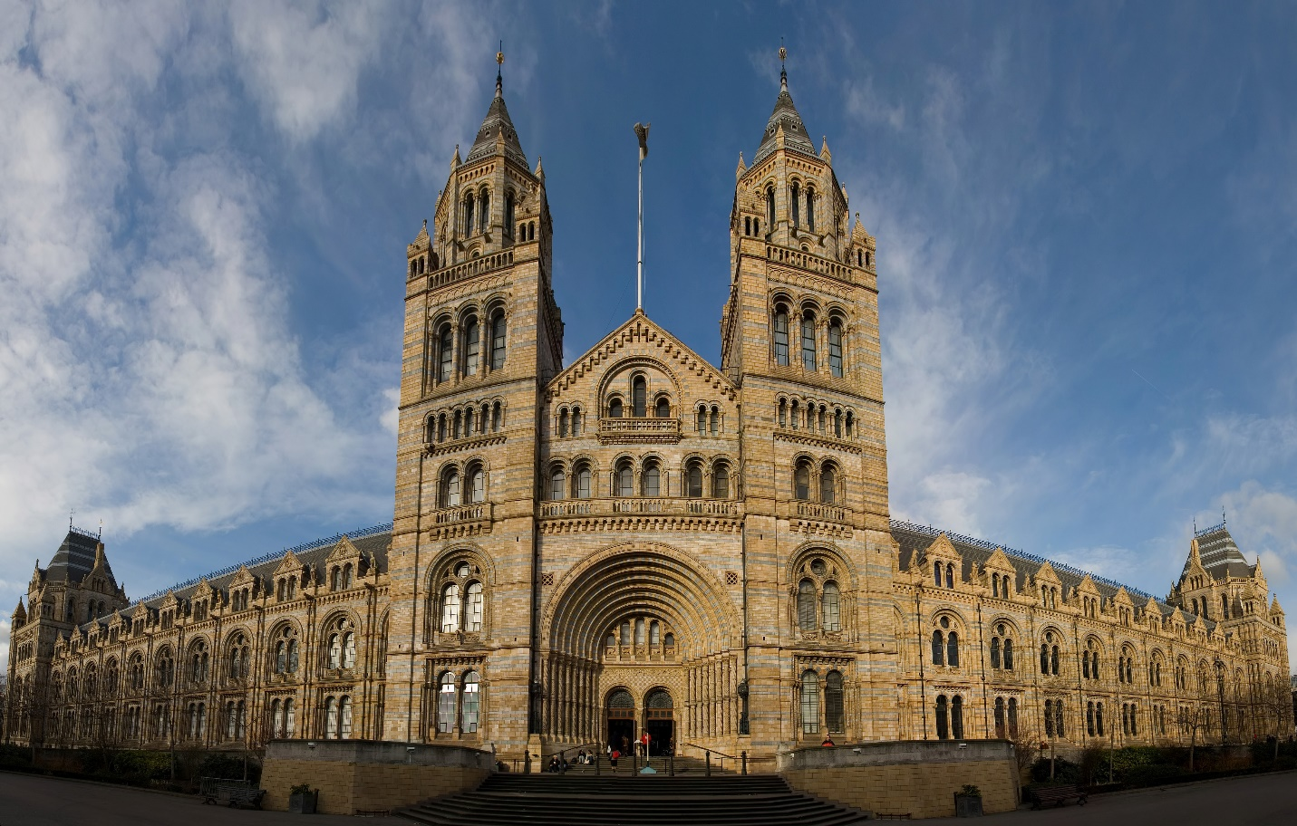
Natural History Museum, London; terracotta façade of Victorian Era

