**INSIDE Only Tour**

**PATH ONE**

**Fourth Grade—Art & Community Museum Tour**

**Fall 2019**

**Big word:** Community

**Big questions:**

* What is public art and why does it exist?
* How do artists collaborate?

**Locations and Artworks**

Central Court: Exhibition *knowledges*

1. Andrew S. Yang, born 1973

*Deep Time Library*, 2019

From Theory of the Earth, Volume IV

On loan courtesy of the artist, IA2019.001.02

Flex Space

1. Time Activity

Gallery 405: 20/21 Gallery

1. Louise Nevelson (1899-1988)

*Young Tree XXII*, 1971

wood, paint

Gift of Mrs. Louis Sosland, 1977.0089

1. Roger Shimomura, born 1939

*Dinner Conversation with Nancy*, 1983

acrylic on canvas,

Gift of the artist in memory of Nancy Anne Zimmerman, 1988.0067

1. Dale Chihuly, born 1941

*Violet Persian Set with Red Lip Wraps*, 1990

blown glass

Museum Purchase, 1992.0002

Gallery 407: This Land

1. Art for the Community Activity
2. Maria Martinez, artist 1887-1980  
   Julian Martinez, painter 1897-1943  
   *blackware olla (vase),* 1934-43  
   ceramic, paint  
   Gift, 1972.0449
3. Drawing Activity

Gallery 406: The Object Speaks

1. Dale Chihuly, born 1941

*Persian Wall*, 1996

blown glass

Museum Purchase, 1996.0093

1. New Installation Activity

Gallery 405: 20/21 Gallery

1. John Steuart Curry (1897-1946)

*Sketch for Tragic Prelude*, 1937

oil on canvas,

Gift of Mr. and Mrs. C.L. Burt, Hutchinson, Kansas, 1957.0058

**Day of Your Tour:**

1. Arrive at the museum **15 minutes before** your tour is to begin.

2. Speak with the other docent about whether you will place props in the galleries or each carry them with you on the tour.

3. Determine the PATH each docent will take. Path options are listed below.

4. When your tour arrives, please talk with the teacher and other adults accompanying the tour about staying with group, modelling focus on the tour, and assisting with insuring the safety of the students and works of art in the museum.

**Path One:**

Central Court

* Deep Time Library

Flex Space

* Time Activity

Gallery 405: 20/21

* Young Tree XXII
* Dinner Conversation with Nancy
* Violet Persian Set

Gallery 407: Forms of Thought

&This Land

* Art for Your Community Activity
* Blackware olia
* Drawing Activity

Gallery 406: The Object Speaks

* Persian Wall
* New Installation Activity

Gallery 405: 20/21

* Tragic Prelude

**Path Two:**

Gallery 406: The Object Speaks

* Persian Wall
* New Installation Activity

Gallery 405: 20/21

* Tragic Prelude

Gallery 405: 20/21

* Violet Persian Set
* Dinner Conversation with Nancy
* Young Tree XXII

Gallery 407: Forms of Thought

&This Land

* Art for Your Community Activity
* Blackware olia
* Drawing Activity

Central Court

* Deep Time Library

Flex Space

* Time Activity

***Welcome:***

Welcome to the Spencer Museum of Art! We are very happy to have you visit today and hope that you will come back again. My name is _______ and I am a docent, or volunteer tour guide, at the Spencer.

* Raise your hand if you have visited the Spencer before. Raise your hand if you’ve visited any kind of museum?

***Rules:***

* Before we begin your tour, please nod if you remember talking about art museum rules back at your school.

**What are some art museum rules?** Be sure to raise your hand if you have an answer. We want to be sure to hear what everyone has to say, and so during the tour, please also remember to raise your hand. What does your teacher do to get your attention?

* Be good listeners.
* Use a polite voice.
* Stay within sight of your teacher or docent.
* Remember your museum hands:
  + Museum hands stay close to your body.
  + Look with your eyes and not with your hands.
* Leave a person-sized space between you and the works of art, cases, and walls

***Tour Introduction***

***Give land acknowledgement before beginning the tour:***

We at the Spencer Museum of Art collectively acknowledge that the University of Kansas occupies the historical homelands of the Kansa (Kaw), Shawnee, and Osage People. We also recognize and advocate for the sovereignty of the tribes who currently reside in Kansas: the Iowa Tribe of Kansas and Nebraska, the Kickapoo Tribe in Kansas, the Prairie Band Potawatomi Nation, and the Sac and Fox Nation of Missouri in Kansas and Nebraska, as well as members of the Delaware, Quapaw, and Wyandot nations. We affirm Indigenous sovereignty, support the needs of American Indian peoples, and commit to Indigenizing the Spencer Museum of Art.

**Let’s get started:**

* Do you remember visiting Spencer Museum of Art last spring? We learned about how artists tell stories through works of art and museums tell stories through exhibitions.
* Today we will be learning about

1. how community impacts artists
2. how artists collaborate
3. and artists that make public art

* Let’s begin by answering this question.
  + What is an example of a community?
  + There can be many different kinds of community, can’t there?
  + city, neighborhood, school, club, church, etc.
* We will be looking at different ways community has been important to artists and how it has affected their work.

You will look closely at works of art with all of your classmates and participate in group activities in the galleries (rooms of the Museum). We will also go outside to look at work of arts!

**Central Court**

**1**

## Gallery[Andrew S. Yang](https://spencerartapps.ku.edu/collection-search#/Artist/27270)

born 1973

## Deep Time Library

2019

from *Theory of the Earth, Volume IV*

Where object was made: United States

salvaged books, geological specimens

Courtesy of the artist

IA2019.001.01

**Visualizing Deep Time**

How old do you think the earth is?

Geologists think the Earth is about 4.54 billion years old.

* Geologists: scientists who study the solids, liquids, and gases that make up the earth

This number is so large he it is hard to understand. We just know it means a whole lot, right?

The artist Andrew Yang created this sculpture to help us understand the enormously long time that the earth has been around.

He decided that each page (front and back) would stand for a certain number of years.

How many numbers do you think each page stands for?

10? 100? 1 million?.................

He chose 10,000 years for each page because that is thought to make up ALL of the history of human civilization.

Raise up your hands if you think 10,000 years is a whole lot of time. And it is only one page of 454,000 pages in this stack of books.

Time is a very big idea and we are going to explore it a little more through a community activity in the Museum’s Flex Space.

Collaboration

But before we do that, I have one more question.

Do you think the artist Andrew Yang made this sculpture all by himself or do you think he had help?

This was a very big task and so he needed help. He had assistants who worked with him to sort and stack the books for this sculpture.

Docent Information

Geologists state that the Earth is 4.54 billion years old—plus or minus 50 million years. That number is so large and abstract that within our experiences of time it simply means “a whole lot.” Even so, these details provide important context for understanding the planet’s dynamics and the roles humans play within them. Deep Time Library & Archive is a scale-model of Earth’s deep geological history in which just one page front and back from one of these books represents 10,000 years. That is about the number of years that is thought to make up the history of human civilization. This installation uses approximately 454,000 book pages to represent the age of the Earth. This bibliographic rock face creates layers of time and knowledge. What is preserved as part of a definitive record and what is discarded or transformed into something new? How is information best stored and retrieved over the long run, and what is the “long run”? These are questions that geologists and archaeologists ask about rocks and soils just as much as historians and librarians consider them while archiving printed materials. The books included in this exhibition have been through book sales and offered to secondary retailers. This installation is their last appearance before recycling, which keeps them out of landfills. The artist also understands their longer lives as part of the carbon cycle. A very warm thank you to KU Recycling, the Lawrence Public Library, and the John M. Flaxman Library at the School of the Art Institute of Chicago for their support of this work and for being responsible stewards of these cultural materials.

**Lobby Flex Space (behind the Visitor Experience Desk)**

**2**  **Time Activity**

This activity will give you the chance to be a part of a collaborative art project with all the other 4th graders in the Lawrence school district. Today, you will add to our own tower of books about time.

Each of you will receive a pencil and a piece of paper shaped like the spine of a book.

There will be the beginning of a statement on the paper. You will finish the statement by writing something.

When you are done, hand your pencil and paper to me so that your ideas about time can be added to our Tower of Time.

OR you could tell the students:

When you are done, take a magnet and attach your book spine to the big white wall. Ask a grown up for help if you need it.

**Book Spine Prompts:**

Book spine—

Time is………………………………….

Time is___________________

When I think of time, I imagine___________________

Time is like___________________________

Time makes me feel______________________

Time seems to stand still when ______________________

Time flies when____________________________

**Gallery 405: *20/21***

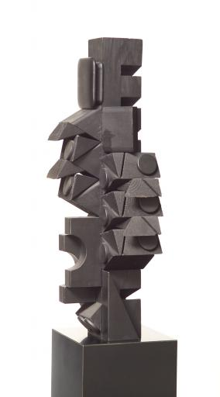

**3 Louise Nevelson 4th-Grade Focus Artist**

***Young Tree XXII*, 1971**

**wood, paint**

**Gift of Mrs. Louis Sosland, 1977.0089**

Close Looking

The artist Louise Nevelson created this work of art, and she also made public art that was designed to be displayed outside. When we’re done looking at this sculpture, we’ll explore one of Nevelson’s public works of art.

**Elements of Art Activity**

* Ask students to get into the same groups they were in before.
* Assign each group an element of art
* Ask them to look for examples of their element in the sculpture and brainstorm words to describe them
  + For example if they got the card color: black, dark, monochromatic (only one color)
* After a minute, ask groups to share what they found

Now that we’ve spent some time talking about how this sculpture looks, let’s talk about how we think it was made.

Do you think it was made by carving, casting, or assembling? (You can talk with the students about what each of these processes are—simple explanation)

* Carving—cutting away material from a larger piece
* Casting—pouring material, like molten metal, into a mold and letting it solidify into a form
* Assembling—putting multiple pieces together to create a form

Why do you think this is assembling?

What do you think the material is? Wood Why do you think that?

Have someone look at the label to find the title. *Young Tree XXII*. How is this sculpture like a young tree? size, material, shape, use of children’s blocks

There is another much larger sculpture by Louise Nevelson in front of the Museum. You may have a chance to see it as you are walking to the bus at the end of the tour. The work of art in front of the Museum would be called a **PUBLIC SCULPTURE**.

* Why would a sculpture outside in front of the Museum be called a public sculpture? What does that mean?
  + It is being shown in a public space where anyone can see it.

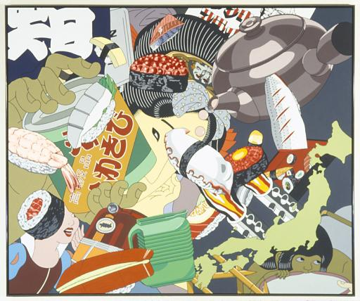

**4 Roger Shimomura 4th-Grade Focus Artist**

**United States, born 1939**

***Dinner Conversation with Nancy*,**

**1983**

**Acrylic on canvas, 1988.0067**

Close Looking

We’ve spent quite a bit of time looking at sculptures today. Now we are going to look at a painting.

*Docents point out* Dinner Conversation with Nancy*.*

**Picture Clues Activity:**

* Tell students:
  + We are going to get back into our small groups again.
  + Each group will be given a Clue Card
  + Work together in your group to find things in this painting that match your Clue Card
* Give students about a minute to find things.
* Have each group share what they found.

**Clue Cards:** people, food, cookware or dishes, map, transportation, writing

Artist & Community

The artist Roger Shimomura included things from two countries in this painting. What countries do you think they are? USA, Japan (*Students might say China or Asia—Objects from Asia have some shared characteristics that can make them difficult to tell apart if you are not familiar with the individual traditions and styles.)*

Roger Shimomura is Japanese American. He was born and grew up in the United States, but his grandparents immigrated (permanently moved) from Japan to the U.S. This painting is like an autobiography (story about yourself), showing American and Japanese things overlapping and swirling together in a collage of pictures.

What things look like they are from the United States?

* Snow White
* Kentucky Fried Chicken
* Train
* Pitcher

What things look like they are from Japan

* Sushi
* Map of Japan
* Japanese woman
* Teapot
* Can of wasabi (green horseradish) powder

Roger Shimomura’s art might help us think about how complicated identity can be. People make assumptions about Shimomura because he looks Japanese, but he was born in the United States. While his grandparents were from Japan, he is American, and that is his experience and his community.

Docent Information

Shimomura titled the painting *Dinner Conversation with Nancy* because he had a very good friend Nancy who threw amazing dinner parties where people had wonderful conversations about lots of different things. Roger Shimomura is a Japanese-American who lives and works in Lawrence. He taught painting at KU for many years.

Painting includes:

* Mowgli, a little boy raised by wolves, from The Jungle Book
* Objects are of real things, but the space isn’t realistic. The artist has **layered the shapes** one on top of another like a **collage**.

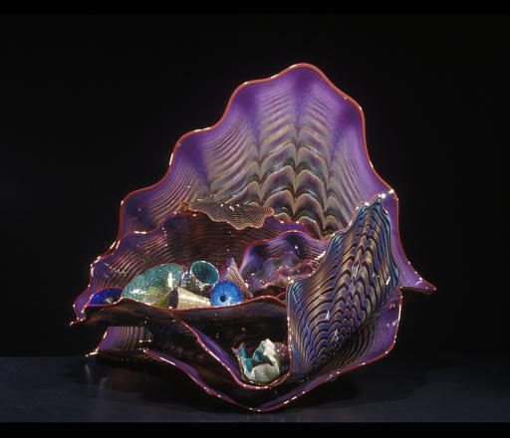

**5**

**Dale Chihuly 4th-Grade Focus Artist**

***Violet Persian Set with Red Lip Wraps*, 1990**

**blown glass**

**Museum Purchase, 1992.0002**

Close Looking

We are going to see another work of art by this artist later on in your tour.

What are some things that stand out about this work of art?

Have someone look at the label to find the artist and title.

Gallery 407: Forms of Thought

**6 Art for Your Community Activity**

At the beginning of your visit today, we talked about how your school is one of the communities that you belong to.

Do you have art in your school, or not?

Who do you think chooses what art is displayed at your school?

Well today, each group is going to pick a work of art from this gallery that they think should be displayed in your school.

Once you have decided on a work of art, identify two reasons why it should be displayed in your school.

Remember, you are not choosing this work of art for yourself.

You are choosing it for your school community.

Think about all the different students, teachers, and staff at your school. What would they like? What would they feel a connection to? Try to think about their experiences, feelings, and interests.

*Docents give the space parameters. Have students only use spaces in* Forms of Thought*. Ask teacher/parent to help students and make sure they stay in the designated spaces.*

Be sure to walk

You’ll have a few minutes to find your work of art and identify two reasons why it should be displayed in your school. This means you will need to stay focused on your task to get done in time.

Once we are done, we will have each group share what they chose and make their arguments to the group for why it should be displayed at your school.

Then have the students vote for which work of art they think should go in their school. They can’t vote for the work of art they chose. Have a few students explain the reason for their vote.

**Gallery 407: This Land**

**7**

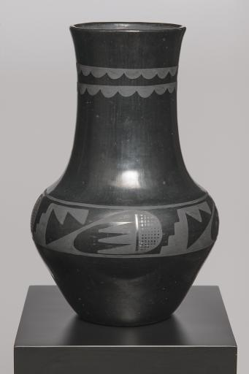Maria Martinez, artist (San Ildefonso), 1887-1980  
Julian Martinez, painter (San Ildefonso), 1897-1943  
*blackware olla (vase),* 1934-43  
San Ildefonso Pueblo, New Mexico, United States  
ceramic, paint  
Gift, 1972.0449

* Where do you see changes in texture? What kinds of textures do you see?
* How do you think the artists made the olla both shiny and dull?

The shiny areas were made by polishing the vase. The duller areas were created by painting the vase with slip, which is a water and clay mixture.

This vase or *olla* (oy-ya) was created by Maria and Julian Martinez. Maria and Julian were husband and wife, and worked together to complete the work. They were from San Ildefonso Pueblo, a Native American reservation, in New Mexico. Family collaboration was a very important part of how they worked and how their children continue to work. **(Collaboration and Community)**

* They found their clay from the land around the Pueblo and would collect it as a family.
* Maria would start each piece of pottery as a pinch pot and then smooth out the edges. Once the clay dried, she would alter the texture on the outside of the olla by polishing it.
* Julian would paint with slip to create the shapes on the olla. He painted the areas around the shapes (the negative space) in order to create the design.
  + Are the shapes in the design shiny or dull? The dull areas are where Julian painted in order to create shiny shapes on the vase.

*Props of process*

* The pottery would start off red or brown, but during the firing, the clay becomes black.
  + This technique was forgotten by the San Ildefonso. Maria talked to a neighboring Native American tribe, the Santa Clara Pueblo, who had practiced this kind of firing for a long time and they shared the process with her. *Prop of firing outside*

This black on black pottery was made to be sold and many museums around the world now have pottery by Maria and Julian in their collections, just like this museum.

It has also become a symbol of great pride in the San Ildefonso and Santa Clara Pueblo communities and has impacted many artists working today. **(Community)** *Prop of El Camino “Maria”*

**Docent Information**

**About the name:** Olla is Spanish and means pot.

**About painting**: When Julian died, their son Popovi Da took over painting the pottery. Sometimes his wife helps, too. They are teaching their son how to make the pottery and paint it. (the jar in Forms of Thought is painted by Popovi Da)

**About firing:** The secret was to cover the pottery with manure since it has different minerals than dirt and makes the fire burn longer and slower, which impacts the color of the clay. This type of firing makes the clay less water-tight and more brittle, which makes it perfect for selling because it wouldn’t work as well for everyday tasks.

**Drawing Activity**

**8**

Now we’re going to do a drawing activity to learn a little more about creating a design by coloring in the positive space and then by coloring in the negative space

* I’m going to give you each a piece of paper and a pencil.
* There’s a line drawn down the middle of the paper with half a design drawn on one side of the line.
* First, color in the shapes on the half of the paper that has a design. Then create a mirror or reflection of the shapes by coloring in the negative space on the other side of the paper. (show students the example)

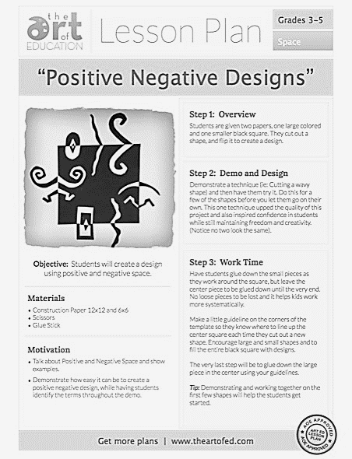

**Gallery 406: The Object Speaks**

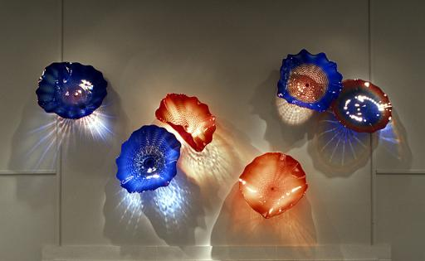

**9**

**Dale Chihuly 4th-Grade Focus Artist**

***Persian Wall*, 1996**

**blown glass**

**Museum Purchase, 1996.0093**

Close Looking

What sculpture have we looked at today that reminds you of this work of art?

* Chihuly in *20/21*

With the exception of the Chihuly sculpture we saw in 20/21, how is this work of art different than the one’s we’ve looked at today?

* Abstract
* Colorful
* Glass
* Many pieces
* Larger
* Light reflections/translucent/bright

I might use the word vibrant to describe this sculpture. What words would you use?

What do the shapes and colors remind you of? sea shells

The artist Dale Chihuly often thinks of shell shapes and the vibrant colors and patterns of Persian carpets. He also thinks about Italian art glass—especially from the city of Venice. Chihuly, actually, went to Italy to study Venetian glass (glass from Venice)

Props: pictures of Persian carpet and Venetian glass.

**Artist & Collaboration**

Chihuly collaborates with a team of people in his WORKSHOP. Let’s look at the label to see who is listed as the artist. *Docents: ask for a volunteer to look at the label.*

Notice that the label only says Dale Chihuly. The people in his workshop are considered helpers and are not given credit for creating the works of art.

Chihuly imagines ideas and designs works of art, and his assistants create the blown glass sculptures.

Chihuly really likes this team approach. However, because of two accidents during the 1970s (almost 50 years ago), Chihuly has also been unable to blow glass himself.

* He lost his left eye in a car accident, affecting his peripheral vision—seeing things to the side.
  + *Docents: Have students cover their left eyes to see how much of their vision is affected.*
* A body surfing accident left him unable to hold a glassblowing pipe.

**­­­­­­­­­­­­­­­­­­**

**Gallery 406: The Object Speaks**

**10**

**New Installation Activity**

**Artistic Process:**

This work of art was originally on the wall of the Central Court.

* Chihuly visited the Museum and chose the location for the sculpture.
* His #1 assistant visited the Museum to arrange the pieces that had been made in Chihuly’s workshop in Washington state.
* Originally, there were seven pieces in the sculpture. The assistant decided to use only six.
* Once the pieces had been installed on the wall, they could be turned to create different light effects.

The part of the Central Court wall where this sculpture hung no longer exists. *Docents Point to the opening into the Central Court or walk students over to look.* It is now an opening that allows us to look down into the Central Court from the 4th floor of the Museum.

Prop: Picture of Persian Wall on view in Central Court

The Museum’s Exhibition Designer Richard Klocke worked with Chihuly’s studio to find this new home for Persian Wall and to make sure that the artist approved of how it was arranged.

**Activity:**

This isn’t the only way that these pieces could be arranged, is it?

* In a moment we are going to divide into two groups. In your group, we are going to imagine that you are assistants in Chihuly’s workshop.
* It will be each group’s job to find a new way to arrange the pieces of his sculpture.
* Discuss with each other how your new arrangement is different and better than the way Persian Wall is currently displayed.
* We will then come together, and each group will share a few things they like about their new arrangement or the reasons for their choices.

**Gallery 405: 20/21**

**11**

**John Steuart Curry**

**United States, 1897-1946**

***Sketch for Tragic Prelude*, 1937**

**oil on canvas, 1957.0058**

**Artist & Public Art**

The artist John Stueart Curry (Docents: point out self portrait) was hired for a very big job: to paint pictures or murals on the walls of the Kansas State Capitol building in Topeka.

Would a state capitol mural be public art or not? It is public art. Why is that?

The State of Kansas hired Curry to make murals for the state capitol, which is a public building. Anyone can visit the Kansas State Capitol to see Curry’s murals.

Public art is often made in partnership with a business, organization, government, etc. Have any of you ever helped make a mural?

Curry **collaborated** with, or partnered with the State of Kansas to create murals for the capitol.

Curry was a Kansan. He grew up in a **community** near Oskaloosa, KS.

He chose to include things that are connected to Kansas and its history for the murals.

* What do you see in this painting that connects to Kansas and its history?
* Tornado
* Prairie fire
* Civil War soldiers
* John Brown
* Slaves/African Americans
* Covered wagons
* Sunflowers
* Pioneers

However, sometimes when you collaborate it can be difficult to make everyone happy.

Now, I’m going to tell you a story about that:

Not everyone in Kansas was happy with the kinds of things Curry included in his paintings. They would have liked Curry to show a different kind of picture of Kansas.

* What did Curry include in this painting that people might have considered negative or bad? tornado, prairie fire, John Brown
* People would stand and watch Curry paint, criticizing what he was doing. They even told him painting a pig with a curled tail while it was eating was wrong.
* Curry became so frustrated with all of the criticism that he painted a family of skunks in one of the murals and labeled them with the names of his greatest critics. The names were removed, but the skunks remain.

Technique/Media

Aside from the subject of this painting, Curry has included something else around the edges of the picture.

* What do you see?
* This painting is a practice painting for the actual murals that would be painted on the walls of the State Capitol. Curry created a plan for his mural before he started painting on the walls of the State Capitol. He included the doors and walls around the murals in his practice painting. **Prop:** picture of mural in the Statehouse

Cultural and Historical Information

The artist **John Steuart Curry** (point out the self-portrait) was born and raised on a farm just north of Lawrence near Oskaloosa. He wanted his art to **show American life and the things he thought Americans believed in.**

**Symbolism in mural:**

* Tornado and prairie fire both happen in Kansas, but also symbolize the turmoil of the time.
* The man in the middle is **John Brown**. He wanted Kansas to come into the United States as a Free State, without slavery.
* Bible held by John Brown refers to rifles smuggled to abolitionists (people against slavery) in crates labeled Beecher’s Bibles.
* Soldiers at the feet of John Brown symbolize the many Union and Confederate soldiers that lost their lives.

***Docent Information:***

*This painting is one of the sketches by John Steuart Curry for the murals he painted for the Capitol in Topeka. In his series of three murals, Curry wanted to express the underlying conflicts in the land and the history of his state. This painting is about the conflict over slavery in Kansas.*

*On either side are the warring free soil and proslavery forces,and at their feet, two figures symbolizing the million and half casualties from the Civil War. The background shows the pioneers moving west. The tornado and a raging prairie fire are fitting symbols of the destruction of the coming Civil War.*

*John Brown came to Kansas in the fall of 1854. Although he never made Lawrence his home, he visited the town on many occasions during the late 1850's, and he reportedly was appointed a captain in the Lawrence militia. Brown was not elevated to martyrdom in Kansas until after he left the territory and became a national figure at Harper's Ferry in 1859. As part of a plan for an uprising among slaves, he led a raid on an arsenal at Harper's Ferry, Virginia (now West Virginia). He was hanged for treason.*

***Conclusion:***Today we looked a works of art in the museum and talked about public art and artists & their communities. We also explored how artists collaborate.

* What artists made public art? What kind of art did they make?
  + Nevelson-sculpture
  + Curry-mural
* What communities did artist draw upon for ideas for their art?
  + Artists look to their communities for ideas and messages (Martinez, Curry)
  + Artists look to their family history and traditions (Shimomura, Martinez)
  + Artists think about how their identity is shaped by their communities (Shimomura-Japanese/American)
* Who did Dale Chihuly collaborate with to make his blown glass sculptures? workshop assistants
* Who did Curry collaborate, or partner, with to make his Kansas State Capitol murals? State of Kansas

Tell me about an artwork that you saw today that made you think of community.

What was your favorite work of art? Why?

***Invitation to Return:***

We are going to give your teacher Collection Card mystery packs. She will decide when to give them to you.

* Spencer Collection Cards have works of art from the Spencer Museum of Art.
* We give cards away during School Programs and Youth & Family programs.
* You can collect and trade your cards and create your own Collection Card exhibitions.
* Be sure to go to the Collection Card website printed on your card and enter the “secret code” to find out more about the work of art on your card.

**Prop:** Collection Card

I hope that you’ve enjoyed visiting the Museum with me today, and I hope that you will be able to come back soon and show your family and friends the art that you have seen, look at some new art, and learn new stories.

**Supplemental Works of Art**

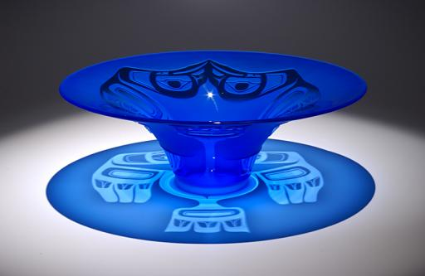

**Preston Singletary**

***Eagle Hat*, 2003**

**Blown glass, sandblasting**

**Museum Purchase, 2003.0075**

Close Looking

Now let’s compare this work of art to *Persian Wall* by Dale Chihuly.

* How are they similar? Blue, bright color, round, glass (blown), light reflection, etc.
* How are they different? design (sandblasting), shape (more 3-dimensional like a vase), only one color, installation (pedestal vs. wall), one versus 6 pieces, etc.

Artist & Community

These two artists, actually, have an interesting connection. Dale Chihuly founded, or began, the Pilchuck Glass School outside of Seattle, Washington and this artist Preston Singletary attended the Pilchuk School as a student.

However, while Chihuly’s work, Persian Wall, is influenced by shells, Persian carpets, and Venetian glass—Singletary got his ideas from his clan—which is a kind of community.

* Raise your hand if you know what a tribe is.

A clan is another word for tribe, which is used by Native Americans in the American Northwest—for example the states of Washington or Oregon. Singletary is a member of the Tlingit clan. Prop: map of United States

Let’s look more closely at the design on Singletary’s work.

* What do you think it is? It’s kind of hard to tell, isn’t it?
* Ask students to stay seated, but look with their eyes around the gallery to see if they see any designs similar in style. Totem pole

The totem pole and this glass piece were both made by artists from places not too far from each other—and with similar family connections.

What you are seeing is an eagle design. You might not recognize it if you are not familiar with this style of art and the Native American traditions in which Singletary grew up.

The eagle is a special clan symbol that can ONLY be created by members of the clan. Other clan signs for Singletary’s family are the Killer Whale, Brown Bear, and Wolf.

The vase form that you are seeing is, actually, the shape of a traditional Tlingit hat turned upside down. Why do you think Singletary shows the hat upside down? How would what we see change if we turned the hat right-side up? Reflection of the eagle design on the base. Prop: Picture of traditional Tlingit hat.

What community is the artist Preston Singletary looking to for the subjects of his art? His family/clan.

**Supplemental Works of Art**

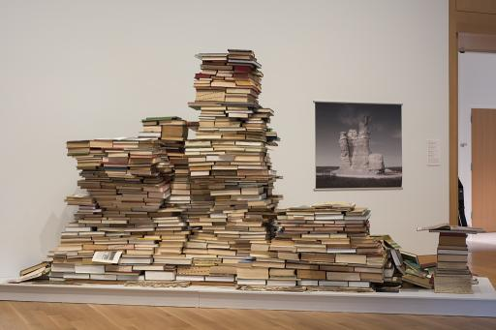

## Andrew S. Yang, born 1973

## Reading the Landscape

## (Ancient Ocean Testament:

## Castle Rock, Kanseas), 2019

**from *Theory of the Earth,***

***Volume IV***

**salvaged books, geological**

**specimens**

**Courtesy of the artist,**

**IA2019.001.02**

What really stands out about this work of art?

How are the structures in these photographs similar to this sculpture?

How is it different?

Sculpture Information:

* As dirt, rocks, and plants pile on top of each other, they create different colored layers, like the ones you see in the photograph.
* The artist used this idea as the inspiration for piling books on top of each other to make layers that look kind of like the land in the photos.
* The artist Andrew Yang created **composite images of photographs** (one photograph created by combining two or more photographs) originally taken by John Charlton, who worked for the Kansas Geological Survey. The multiple photographs show how the landscape has changed over time.
  + Why do you think parts of the pictures looks kind of transparent or ghostly?
    - In the 30 to 40 year time period that Charlton took these pictures, the towers of rock fell.

*If you have the time, you can look at the other Martinez ceramic in the case against the wall with La Pia to compare different symbols, style of the symbols, and shape of the work of art:

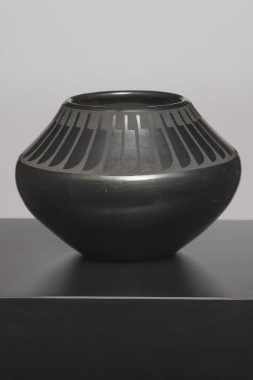**Maria Martinez, artist (San Ildefonso)  
Popovi Da, painter (San Ildefonso)  
*jar with feather design*   
1964  
San Ildefonso Pueblo, New Mexico, United States  
ceramic, paint  
Gift of Francis Heller  
2003**